**Data journalist education background overview**

To become a data journalist, working experience and professional skills are quite important during one’s career. There are two ways to gain knowledge about data journalism, one is through online learning program, the other one is college education. However, not so many universities have conduct programs to aimly teach none data jouranlist backgrounds students to become a speicalist in the field of data journalism. Across the USA, only one universities have the program named after ‘data journalism’ and another one emphsis data journalism but didn’t use it to name the program, while other universities’ school of communication just have relative selevtive courses to follow the trend.

Comparison of two crriculum in two universities

|  |  |  |  |  |  |  |  |
| --- | --- | --- | --- | --- | --- | --- | --- |
| School name | Columbia University | | | Standford university, | | | |
| Program name | M.S. Data Journalism | | | Journalism | | | |
|  | Required courses | | | Selective courses | | | |
| Course name | Foundations of Computing | | Journalistic Computing | Required courses | | Selective courses | |
|  | Data & Databases | Multimedia Storytelling: Data, Design and Animation | | | Perspectives on American Journalism | | [Moving Pictures – How the Web, Mobile & Tablets are Revolutionizing Video Journalism](https://explorecourses.stanford.edu/search?view=catalog&filter-coursestatus-Active=on&page=0&catalog=&academicYear=&q=COMM+271&collapse=) |
| Data Analysis Studio | Using Data to Investigate Across Borders | | | [Public Affairs Data Journalism I](http://www.padjo.org/) | | [Advanced Digital Media Production](https://explorecourses.stanford.edu/search?view=catalog&filter-coursestatus-Active=on&page=0&catalog=&academicYear=&q=COMM+276&collapse=) |
| Project practising |  | | | [Multimedia Storytelling](https://explorecourses.stanford.edu/search?view=catalog&filter-coursestatus-Active=on&page=0&catalog=&academicYear=&q=COMM+275+Multimedia+Storytelling&collapse=) | | [Science & Environmental Journalism](https://explorecourses.stanford.edu/search?view=catalog&filter-coursestatus-Active=on&page=0&catalog=&academicYear=&q=COMM+277C&collapse=) |
| Written Word |  | | | [News Reporting + Writing Fundamentals](https://explorecourses.stanford.edu/search?view=catalog&filter-coursestatus-Active=on&page=0&catalog=&q=COMM+279&collapse=) | | [Narrative Journalism](https://explorecourses.stanford.edu/search?view=catalog&filter-coursestatus-Active=on&page=0&catalog=&academicYear=&q=comm+277d&collapse=) |
| Data, Computation, Innovation Workshop I: Storytelling with Data |  | | | [Journalism Law](https://explorecourses.stanford.edu/search?view=catalog&filter-coursestatus-Active=on&page=0&catalog=&academicYear=&q=COMM+216&collapse=) | | [Becoming a Watchdog](https://explorecourses.stanford.edu/search?view=catalog&filter-coursestatus-Active=on&page=0&catalog=&academicYear=&q=COMM+277I&collapse=) |
| Data, Computation, Innovation Workshop II: Algorithms |  | | | [Public Affairs Data Journalism II](http://storybytes.org/) | | [Programming in Journalism](http://journalism.stanford.edu/curriculum/) |
|  |  | | | [Journalism Thesis](https://explorecourses.stanford.edu/search?view=catalog&filter-coursestatus-Active=on&page=0&catalog=&academicYear=&q=COMM+289P&collapse=) | | [Sports Journalism](https://explorecourses.stanford.edu/search?view=catalog&filter-coursestatus-Active=on&page=0&catalog=&academicYear=&q=COMM+277S&collapse=) |

P.S. Columbia Universitty offers selective courses which vary each semester depending on faculty availability and other considerations. The above selevtive courses is the openning courses this semester.

From above, although two universities have accordingly design the courses for better education in the field of data journalism, each universities has its own characteristic. For example, while Columbia University focus more on data computing and data analyzing, Standford University tend to focus on comprehensive journalism teaching and storytelling, which not just about data analysis, but also about how to find story in each database. However, both universities strongly introduce the teaching requirement for students to learn how to use data analysis tools such as, Python, SQL and other software and platforms.

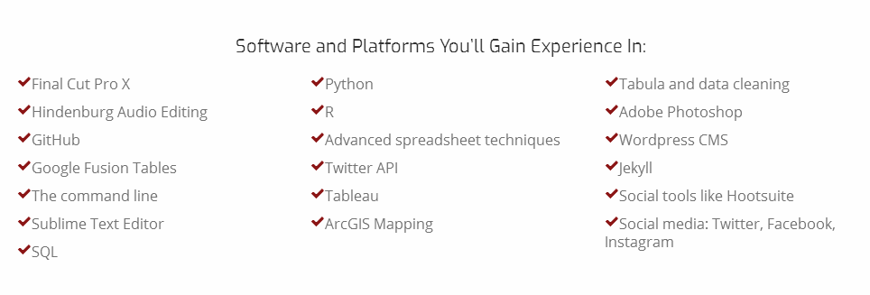

## *‘We’re all about storytelling — and there are countless stories to be told that can be discovered with data. At Stanford, you’ll learn how to use data to boost your multimedia reporting to the next level.’ — introduction of the course and partial learing outcome from Standford Univeristy.*

## Speaking of online learing, the most regular method to access the field to data jouralism is by searching on the internet, joinning forums discussion and buying online courses. For instance, many website like ‘http://datajournalismcourse.net’ , which offers free introduction course to help people to be familiar with data mining, web scraping and other method that regularly being talked about in data journalism. However, the total quality of the learning matierials is quite difficult to estimate, because these online sources are usually generate by individual user or for-profit organizations, in other words, they are unoffical.

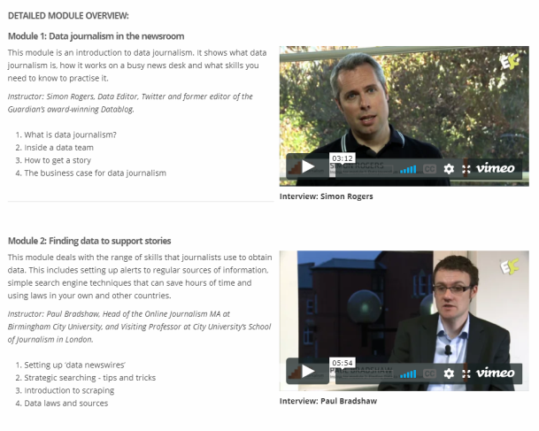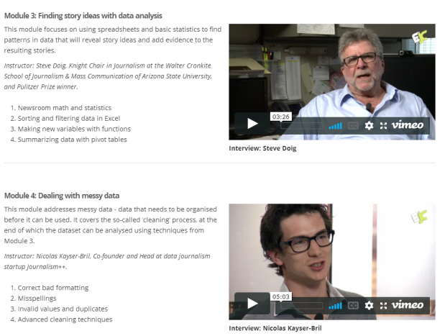

*Free online courses from ‘http://datajournalismcourse.net/course.php’*

In conclusion, like other other occupations in society, which may not have a relevant major in university studies, data journalist is a upcoming trend for those who aspire to become a media specialist to choose for his/her dream profession. Likewise, data journalism should be add into the university’s major in order to further apply the media knowledge to social practice.

Fink, K., & Columbia University. Communications. (2014). *Data-Driven Sourcing How Journalists Use Digital Search Tools to Decide What's News.*

*Standford_Journalism, Curriculum,* [*http://journalism.stanford.edu/curriculum/*](http://journalism.stanford.edu/curriculum/)

*Columbia Journalism School, M.S. Data Journalism, Crriculum,* [*https://journalism.columbia.edu/ms-data-journalism#Curriculum*](https://journalism.columbia.edu/ms-data-journalism#Curriculum)

*Doing Journalism with Data:First Steps, Skills and Tools,* [*http://datajournalismcourse.net/course.php*](http://datajournalismcourse.net/course.php)

数据新闻记者行业现状

开篇：